**VELAMMAL BODHI CAMPUS**

**GRAND TEST -2**

**Class : X**

**Subject : Mathematics -Batch II**

**Duration**

**: 3 Hrs.**

**Maximum marks : 80**

**General Instructions:**

**MMAL BODHI CAMPUS**

**GRAND TEST -2**

**Class : X Duration : 3 Hrs.**

1.This Question Paper has 5 Sections A,B,C,D and E. 2.Section A has 20 MCQs carrying 01 mark each.

3.Section B has 5 questions carrying 02 marks each. 4.Section C has 6 questions carrying 03 marks each. 5.Section D has 4 questions carrying 05 marks each.

1. Section E has 3 case based integrated units of assessment (04 marks each) with sub-parts of the values of 1,1

and 2 marks each respectively.

1. All Questions are compulsory. However, an internal choice in 2 Qs of 5 marks, 2 Qs of

3 marks and 2 Questions of 2 marks has been provided, An internal choice has been provided in the 2 marks questions of Section E.

1. Draw neat figures wherever required, take π = 22/7 wherever required if not stated.

# SECTION A

**I. Section A consists of 20 questions of 1 mark each.**

1.For any two positive integers a and b, what is the value of H.C.F (a,b) x L.C.M (a,b) (a)a2b (b) ab2 (c) ab (d) a + b 2.If one root of the equation 2x2-5x+(k-6)=0 be the reciprocal of the other then k=? (a)k= -8 (b)k=8 (c)k=4 (d)k= -4 3.The distance of the point P(-3,-4) from the x axis is

(a)5 units (b)-3 units (c)3 units (d)4 units 4.For what values of k, -3 is a zero of the polynomial x2+11x+k?

(a)0 (b)24 (c)12 (d)-8

1. The sum of the natural number from 51 to 100 is

(a)3005 (b)2895 (c)375 (d)3775

1. The midpoint of the line segment joining the points (-2,4) and (6,10) is (a)(2,7) (b)(5,2) (c)(3,5) (d)(4,5)
2. The perimeter of the triangle with vertices (0,4),(0,0) and (3,0) is

(a)5 (b)12 (c)11 (d)7+

1. Δ ABC ~ Δ DEF such that 2AB=DE and BC=8cm then find EF

(a)16cm (b)14cm (c)12cm (d)15cm

1. If PA and PB are two tangents to a circle with centre O such that ∠AOB=1100 then

∠APB=?

(a)1200 (b)900 (c)600 (d)700

1. If the perimeter of a circle is equal to that of a square, then the ratio of their areas is (a)22:7 (b)14:11 (c)7:22 (d)11:14
2. If Cos(A+B)=0 and Sin(A-B)= √3/2 then the value of A is

(a)300 (b)600 (c)750 (d)800 12. Sin2600 - 2tan450 - cos2300=?

(a) 2 (b) -2 (c)1 (d)-1

1. If the ratio of length of the rod to its shadow is 1:√3 then, angle of elevation of the sun is (a)300 (b)600 (c)450 (d)900
2. In a circle of radius 3cm, a point lies 5cm away from its centre, what is the length of the tangent to the circle through this point?

(a)3cm (b)4cm (c) 9cm (d)1cm

1. In a circle of radius 14cm, an arc subtends an angle of 450 at the centre, then the area of sector is

(a)71cm2 (b)76cm2 (c)77cm2 (d)154cm2 16.The Probability of getting a number which is neither prime nor composite in a single throw of a dice is

(a)  (b)  (c)  (d) 

17.A letter is drawn at random from the letter of the word ERROR. What is probability that the drawn letter is R.

(a)  (b)  (c)  (d) 

1. The median and mode respectively of a frequency distribution are 26 and 29.Then its mean is

(a) 27.5 (b)24.5 (c)28.4 (d)25.8

Question no. 19 and 20 is based on Assertion (A) and Reason (R), Answer these questions selecting the appropriate option given below:

1. Both A and R are true and R is the correct explanation of A
2. Both A and R are true but R is not the correct explanation of A
3. A is true, R is false (d) A is false, R is true
4. Assertion(A) : If nth term of an AP is 7-4n, then its common difference is -4.

Reason(R) : Common difference of an AP is given by d=an+1-an 20.Assertion(A) : Circumference of a circle is 176cm, then its radius is 22cm.

Reason(R): Circumference =2𝜋 × radius.

# SECTION B

**II Section B consists of 5 questions of 2 marks each.**

1. 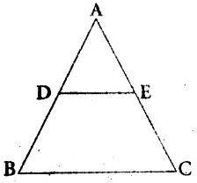Given that √ 3 is irrational, prove that 15+17√ 3 is an irrational.
2. In figure, DE||BC, BD=x-3, BA=2x, CE=x-2, AC=2x+3. Find x. 23.Prove that the angle between the two tangents drawn from an external

point to a circle is supplementary to the angle subtended by the line segment joining the points of contact at the centre.

1. If sin A = cos A, find the value of 2tan2A+Sin2A-1

# (OR)

If x = r cos α.Sin β, y = r sinα.sinβ z= r cos β find x2+y2+z2

1. The area of a circular play ground is 22176 cm2 .find the cost of fencing this ground at the rate of ₹50 per metre.

# SECTION-C

1. **Section C consists of 6 questions of 3 marks each**
2. A seminar is being conducted by an Educational Organisation, where the participants will be educators of different subjects. The number of participants in Hindi, English and Mathematics are 60, 84 and 108 respectively, in each room the same number of participants are to be seated and all of them being in the same subject, hence find maximum number of participants that can accommodated in each room and find the minimum number of rooms required during the event?
3. If α and β are the zeros of polynomial𝑓(𝑥) = 2𝑥2 + 11𝑥 + 5, then find (i) α2 + β2

(ii) 1 + 1 - 2𝛼𝛽

𝛼 𝛽

1. The sum of the numerator and the denominator of a fraction is 4 more than twice the numerator. If 3 is added to each of the numerator and denominator, their ratio becomes 2:3. Find the fraction **(OR)**

Solve the following system of linear equation graphically 3x + y –12 = 0, x-3y+6=0 shade the region bounded by the lines and x-axis, Also find the area of shaded region.

1. Prove that the length of the tangents drawn from an external point to a circle are equal.

# (OR)

Two concentric circles are of radii 5cm and 3cm.Find the length of the chord of the larger circle which touches the smaller circle.

30. Prove that 1

𝑆𝑒𝑐𝐴−1

+ 1

𝑆𝑒𝑐𝐴+1

= 2C𝑜𝑠𝑒𝑐𝐴. C𝑜𝑡𝐴

1. Find the mean age in years from the frequency distribution given below

|  |  |  |  |  |  |  |  |
| --- | --- | --- | --- | --- | --- | --- | --- |
| Class-interval of age in year | 25-29 | 30-34 | 35-39 | 40-44 | 45-49 | 50-54 | 55-59 |
| Frequency | 4 | 14 | 22 | 16 | 6 | 5 | 3 |

# SECTION-D

1. **Section D consists of 4 questions of 5 marks each**
2. Solve the following quadratic equations 9x2- 9(a+b)x+ [2a2+5ab+2b2]=0

# (OR)

1. Find the roots of the equation x2-3√5x+10=0

b) Solve  1 + 2 = 4 ,x≠ -1,-2,-4

𝑥+1 𝑥+2 𝑥+4

1. 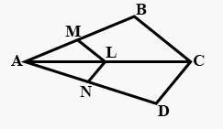a) State and prove Thales theorem.
2. If LM II CB and LN II CD Prove that 𝐴𝑀 = 𝐴𝑁

𝐴𝐵 𝐴𝐷

1. A toy is in the form of a hemisphere surmounted by a right circular cone of the same base radius as that of the hemisphere. If the radius of base of the cone is 21cm and its

volume is 2

3

of the volume of the hemisphere, calculate the height of the cone and the

surface area of the toy. **(OR)**

A solid wooden toy is in the form of a hemisphere surmounted by a cone of same radius. The radius of hemisphere is 3.5cm and the total wood used to making of toy is

166 5

6

cm3. Find the height of the toy also find the cost of painting the hemispherical

part of the toy at the rate of ₹10 per cm2 ( use π =22 )

7

1. If the mode of the following distribution is 65 find the value of x.

|  |  |  |  |  |  |  |
| --- | --- | --- | --- | --- | --- | --- |
| Class interval | 0-20 | 20-40 | 40-60 | 60-80 | 80-100 | 100-120 |
| Frequency | 6 | 8 | x | 12 | 6 | 5 |

# SECTION – E (Case study based Questions)

# Section E consists of 3 questions of 4 marks each.

1. Salary : In investigating different job opportunities, you find that firm A will start you at Rs 25,000 per year and guarantee you a raise of Rs 1,200 each year whereas firm B will start you at Rs 28,000 per year but will guarantee you a raise of only Rs 800 each year. Based on the above information, answer the following questions:
   1. Over a period of 15 years, how much would you receive from firm A?
   2. Over a period of 15 years, how much would you receive from firm B?
   3. What would be your annual salary at firm A for the tenth year?

# (OR)

What would be your annual salary at firm B for the seventh year?

1. Aditya asked carpenter to make front door of his guest house. The carpenter suggested him a design which is plotted on a graph as shown in below figure:

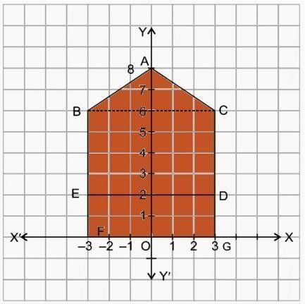

* 1. What is the length of the lines AB? and CG?
  2. Find the coordinates of the mid-point of BE?
  3. If we join BD, then the y-axis divides BD in the ratio:

# (OR)

Find the total area of the given figure in the graph.

1. In a village, group of people complained for an electric fault in their area. On their complained, an electrician reached village to repair an electric fault on a pole of height 5m.she needs to reach a point 1.3m below the top of the pole to undertake the repair work. She used ladder, inclined at an angle of 𝜃 to the horizontal such that cos 𝜃=0.5, to reach the required position.

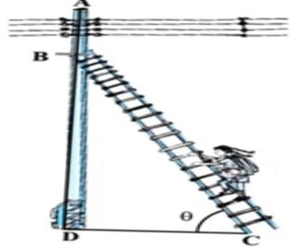

1. Find the angle of elevation 𝜃
2. Find the length of BD
3. Find the length of the Ladder (take √3=1.73)

# (OR)

How far from the foot of the pole should she place the foot of the ladder?

**\*\*\*\* ALL THE BEST \*\*\***